dopisać kondensatory elektr. SMD – size A, B, itd. zobaczyć czy to standard?

dopisać listę obudów z podobnym nazewnictwem – np. SOT23 (JEDEC) => TO-236AB (JEITA)

SOT323 => SC-70 (EIAJ)

SOT-143, SOT-343 => SC-61, SC-82AB

TQFP64 (SOT357-1)

<https://en.wikipedia.org/wiki/Small_Outline_Integrated_Circuit#SOP>

|  |  |  |
| --- | --- | --- |
| Copper Weight | Thickness [µm] | Thickness [mil] |
| 0.5 oz | 17.5 µm (18 µm) | 0.7 mil |
| 1 oz | 35 µm | 1.4 mil |
| 2 oz | 70 µm | 2.8 mil |

|  |  |
| --- | --- |
| SMD Diode | |
| DO-214AC | SMA |
| DO-214AA | SMB |
| DO214AB | SMC |

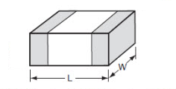

|  |  |  |  |  |  |
| --- | --- | --- | --- | --- | --- |
| FOOTPRINT | | DIMENSIONS [mm] | | POWER RATING | WORKING VOLTAGE |
| EIA [inch] | **IEC [mm]** | **L** | **W** | **[W]** | **[V]** |
| 01005 | 0402 | 0.40 | 0.20 | - |  |
| 0201 | 0603 | 0.60 | 0.30 | 1/20 |  |
| 0402 | 1005 | 1.00 | 0.50 | 1/32 - 1/16 |  |
| 0603 | 1608 | 1.60 | 0.80 | 1/16 - 1/10 |  |
| 0805 | 2012 | 2.00 | 1.25 | 1/10 - 1/8 |  |
| 1206 | 3216 | 3.20 | 1.60 | 1/8 - 1/2 |  |
| 1210 | 3225 | 3.20 | 2.50 | 1/4 - 1/3 |  |
| 1812 | 4532 | 4.50 | 3.20 | - |  |
| 2010 | 5025 | 5.00 | 2.50 | 1/2 |  |
| 2512 | 6332 | 6.30 | 3.20 | 1 |  |

|  |  |
| --- | --- |
| Capacitor Tantalum Value | |
| Picofarad Code | **Value** |
| 100 | 10 p |
| 101 | 100 p |
| 102 | 1 n |
| 103 | 10 n |
| 104 | 100 n |
| 105 | 1 u |
| 106 | 10 u |
| 107 | 100 u |

|  |  |
| --- | --- |
| Capacitor Tantalum Voltage | |
| Voltage Letter | **Voltage** |
| e | 2.5V |
| G | 4V |
| J | 6.3V |
| A | 10V |
| C | 16V |
| D | 20V |
| E | 25V |
| V | 35V |
| H | 50V |

**Tantal Capacitors**

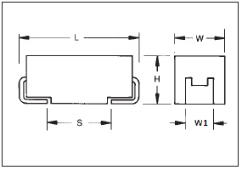

|  |  |  |  |  |  |  |  |
| --- | --- | --- | --- | --- | --- | --- | --- |
| CODE | EIA Code | EIA Metric | L | W | H | W1 | S (min) |
| A | 1206 | 3216-18 | 3.20 | 1.60 | 1.60 | 1.20 | 1.10 |
| B | 1210 | 3528-21 | 3.50 | 2.80 | 1.90 | 2.20 | 1.40 |
| C | 2312 | 6032-28 | 6.00 | 3.20 | 2.60 | 2.20 | 2.90 |
| D | 2917 | 7343-31 | 7.30 | 4.30 | 2.90 | 2.40 | 4.40 |
| E | 2917 | 7343-43 | 7.30 | 4.30 | 4.10 | 2.40 | 4.40 |
| V | 2924 | 7361-38 | 7.30 | 6.10 | 3.45 | 3.10 | 4.40 |

|  |  |
| --- | --- |
| TRACE WIDTH | |
| [mils] | **[mm]** |
| 4 | 0.10 |
| 5 | 0.127 |
| 6 | 0.15 |
| 8 | 0.20 |
| 10 | 0.25 |
| 12 | 0.30 |
| 15 | 0.38 |
| 16 | 0.41 |
| 20 | 0.51 |
| 24 | 0.61 |
| 25 | 0.63 |
| 30 | 0.76 |
| 40 | 1.01 |
| 50 | 1.27 |
| 80 | 2.03 |
| 100 | 2.54 |
| 120 | 3.05 |
| 160 | 4.06 |
| 200 | 5.08 |

|  |  |
| --- | --- |
| EIA Code | Tolerance |
| E6 | 20% |
| E12 | 10% |
| E24 | 5% |
| E48 | 2% |
| E96 | 1% |
| E192 | 0.5, 0.25, 0.1% |

|  |  |  |  |  |  |
| --- | --- | --- | --- | --- | --- |
| **E6 - 20% Resistor Table** | | | | | |
| 100 | 150 | 220 | 330 | 470 | 680 |

|  |  |  |  |  |  |  |  |  |  |  |  |
| --- | --- | --- | --- | --- | --- | --- | --- | --- | --- | --- | --- |
| **E12 - 10% Resistor Table** | | | | | | | | | | | |
| 100 | 120 | 150 | 180 | 220 | 270 | 330 | 390 | 470 | 560 | 680 | 820 |

|  |  |  |  |  |  |  |  |  |  |  |  |
| --- | --- | --- | --- | --- | --- | --- | --- | --- | --- | --- | --- |
| **E24 - 5% Resistor Table** | | | | | | | | | | | |
| 100 | 110 | 120 | 130 | 150 | 160 | 180 | 200 | 220 | 240 | 270 | 300 |
| 330 | 360 | 390 | 430 | 470 | 510 | 560 | 620 | 680 | 750 | 820 | 910 |

|  |  |  |  |  |  |  |  |  |  |  |  |
| --- | --- | --- | --- | --- | --- | --- | --- | --- | --- | --- | --- |
| **E96 - 1% Resistor Table** | | | | | | | | | | | |
| 100 | 102 | 105 | 107 | 110 | 113 | 115 | 118 | 121 | 124 | 127 | 130 |
| 133 | 137 | 140 | 143 | 147 | 150 | 154 | 158 | 162 | 165 | 169 | 174 |
| 178 | 182 | 187 | 191 | 196 | 200 | 205 | 210 | 215 | 221 | 226 | 232 |
| 237 | 243 | 249 | 255 | 261 | 267 | 274 | 280 | 287 | 294 | 301 | 309 |
| 316 | 324 | 332 | 340 | 348 | 357 | 365 | 374 | 383 | 392 | 402 | 412 |
| 422 | 432 | 442 | 453 | 464 | 475 | 487 | 499 | 511 | 523 | 536 | 549 |
| 562 | 576 | 590 | 604 | 619 | 634 | 649 | 665 | 681 | 698 | 715 | 732 |
| 750 | 768 | 787 | 806 | 825 | 845 | 866 | 887 | 909 | 931 | 953 | 976 |

|  |  |  |  |  |  |  |  |  |  |  |  |
| --- | --- | --- | --- | --- | --- | --- | --- | --- | --- | --- | --- |
| **E192 - 0.1%, 0.25%, and 0.5% Resistor Table** | | | | | | | | | | | |
| 100 | 101 | 102 | 104 | 105 | 106 | 107 | 109 | 110 | 111 | 113 | 114 |
| 115 | 117 | 118 | 120 | 121 | 123 | 124 | 126 | 127 | 129 | 130 | 132 |
| 133 | 135 | 137 | 138 | 140 | 142 | 143 | 145 | 147 | 149 | 150 | 152 |
| 154 | 156 | 158 | 160 | 162 | 164 | 165 | 167 | 169 | 172 | 174 | 176 |
| 178 | 180 | 182 | 184 | 187 | 189 | 191 | 193 | 196 | 198 | 200 | 203 |
| 205 | 208 | 210 | 213 | 215 | 218 | 221 | 223 | 226 | 229 | 232 | 234 |
| 237 | 240 | 243 | 246 | 249 | 252 | 255 | 258 | 261 | 264 | 267 | 271 |
| 274 | 277 | 280 | 284 | 287 | 291 | 294 | 298 | 301 | 305 | 309 | 312 |
| 316 | 320 | 324 | 328 | 332 | 336 | 340 | 344 | 348 | 352 | 357 | 361 |
| 365 | 370 | 374 | 379 | 383 | 388 | 392 | 397 | 402 | 407 | 412 | 417 |
| 422 | 427 | 432 | 437 | 442 | 448 | 453 | 459 | 464 | 470 | 475 | 481 |
| 487 | 493 | 499 | 505 | 511 | 517 | 523 | 530 | 536 | 542 | 549 | 556 |
| 562 | 569 | 576 | 583 | 590 | 597 | 604 | 612 | 619 | 626 | 634 | 642 |
| 649 | 657 | 665 | 673 | 681 | 690 | 698 | 706 | 715 | 723 | 732 | 741 |
| 750 | 759 | 768 | 777 | 787 | 796 | 806 | 816 | 825 | 835 | 845 | 856 |
| 866 | 876 | 887 | 898 | 909 | 920 | 931 | 942 | 953 | 965 | 976 | 988 |

|  |  |  |  |  |  |  |  |  |  |  |  |
| --- | --- | --- | --- | --- | --- | --- | --- | --- | --- | --- | --- |
| **E48 - 2% Resistor Table** | | | | | | | | | | | |
| 100 | 105 | 110 | 115 | 121 | 127 | 133 | 140 | 147 | 154 | 162 | 169 |
| 178 | 187 | 196 | 205 | 215 | 226 | 237 | 249 | 261 | 274 | 287 | 301 |
| 316 | 332 | 348 | 365 | 383 | 402 | 422 | 442 | 464 | 487 | 511 | 536 |
| 562 | 590 | 619 | 649 | 681 | 715 | 750 | 787 | 825 | 866 | 909 | 953 |

Resistance Code Value in ohms R56 0.56 5R6 5.6 100 10 271 270 102 1 k 273 27 k 104 100 k 275 2.7 M 106 10 M 107 100 M

Resistance Code Value in ohms R562 0.562 5R62 5.62 56R2 56.2 1000 100 2711 2.71 k 1002 10 k 2713 271 k 1004 1 M 2715 27.1 M 1006 100 M

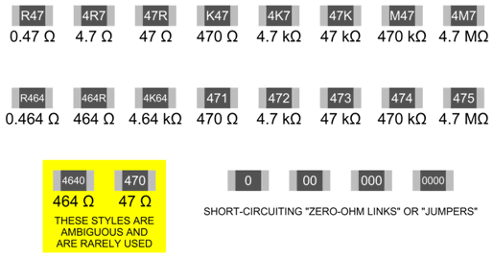

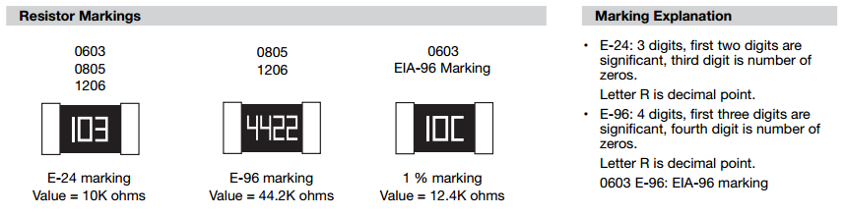

**EIA-96 Marking for Resistors SMD 0603, 1 %**

|  |  |  |
| --- | --- | --- |
| Mark Code | Multipler | |
| Y | 0.1 | - |
| X | 1 | - |
| A | 10 | - |
| B (H) | 100 | - |
| C | 1000 | 1k |
| D | 10'000 | 10k |
| E | 100'000 | 100k |
| F | 1'000'000 | 1M |

|  |  |  |  |  |  |  |  |  |  |  |  |  |  |  |  |
| --- | --- | --- | --- | --- | --- | --- | --- | --- | --- | --- | --- | --- | --- | --- | --- |
| Code | R | Code | R | Code | R | Code | R | Code | R | Code | R | Code | R | Code | R |
| 01 | 10.0 | 13 | 13.3 | 25 | 17.8 | 37 | 23.7 | 49 | 31.6 | 61 | 42.2 | 73 | 56.2 | 85 | 75.0 |
| 02 | 10.2 | 14 | 13.7 | 26 | 18.2 | 38 | 24.3 | 50 | 32.4 | 62 | 43.2 | 74 | 57.6 | 86 | 76.8 |
| 03 | 10.5 | 15 | 14.0 | 27 | 18.7 | 39 | 24.9 | 51 | 33.2 | 63 | 44.2 | 75 | 59.0 | 87 | 78.7 |
| 04 | 10.7 | 16 | 14.3 | 28 | 19.1 | 40 | 25.5 | 52 | 34.0 | 64 | 45.3 | 76 | 60.4 | 88 | 80.6 |
| 05 | 11.0 | 17 | 14.7 | 29 | 19.6 | 41 | 26.1 | 53 | 34.8 | 65 | 46.4 | 77 | 61.9 | 89 | 82.5 |
| 06 | 11.3 | 18 | 15.0 | 30 | 20.0 | 42 | 26.7 | 54 | 35.7 | 66 | 47.5 | 78 | 63.4 | 90 | 84.5 |
| 07 | 11.5 | 19 | 15.4 | 31 | 20.5 | 43 | 27.4 | 55 | 36.5 | 67 | 48.7 | 79 | 64.9 | 91 | 86.6 |
| 08 | 11.8 | 20 | 15.8 | 32 | 21.0 | 44 | 28.0 | 56 | 37.4 | 68 | 49.9 | 80 | 66.5 | 92 | 88.7 |
| 09 | 12.1 | 21 | 16.2 | 33 | 21.5 | 45 | 28.7 | 57 | 38.3 | 69 | 51.1 | 81 | 68.1 | 93 | 90.9 |
| 10 | 12.4 | 22 | 16.5 | 34 | 22.1 | 46 | 29.4 | 58 | 39.2 | 70 | 52.3 | 82 | 69.8 | 94 | 93.1 |
| 11 | 12.7 | 23 | 16.9 | 35 | 22.6 | 47 | 30.1 | 59 | 40.2 | 71 | 53.6 | 83 | 71.5 | 95 | 95.3 |
| 12 | 13.0 | 24 | 17.4 | 36 | 23.2 | 48 | 30.9 | 60 | 41.2 | 72 | 54.9 | 84 | 73.2 | 96 | 97.6 |

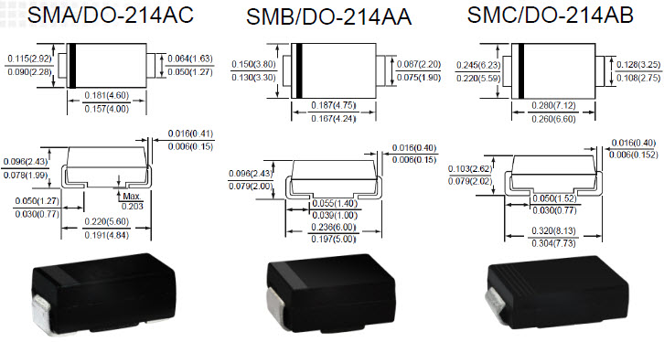

**ENIG** - Electroless Nickel Immersion Gold - pokrycie niklowane z wierzchnią warstwą złocenia

**LF** - Lead Free

**HAL** - Hot Air Leveling

**HASL** - Tin/Lead Hot Air Solder Level - selektywne nanoszenie powłoki cynowo/ołowiowej

**PTH** – Plated Through Hole

**NPTH** – Non-plated Through Hole

**OSP** - Organic Solderability Preservative - powłoka organiczna

**MPCB, MCPCB, IMS, IMPCB** - Metal Core PCB, Metal Clad PCB, Insulated Metal Substrate